Laser Rangefinder Body Roll Control Design Specification

# Overview

This product is designed to simulate wheel slip to prevent the front of a car from rising off the ground during hard acceleration. The device would be connected in between a wheel speed sensor and an engine ECU. Under normal conditions the device would pass through the wheel speed sensor directly to the engine ECU. If the front of the vehicle is detected rising off the ground, the system would increase the number of pulses per second (PPS) of the wheel to the engine ECU to simulate wheel slip. In theory, this should cause the engine ECU to reduce timing to prevent the simulated wheel slip and therefore reduce the front end from rising off the ground.

The system detects front end rise by using a laser rangefinder. The laser rangefinder can detect the small changes in distance from the mounting location to the ground. If the distance is increasing, then the system can increase the number of PPS from the wheel speed sensor to simulate the slip.

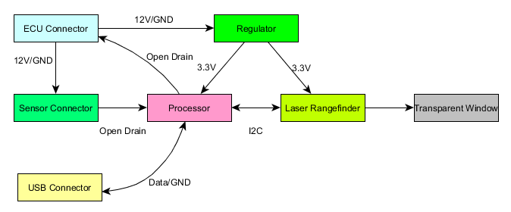

# Hardware Connections

The system will have three connectors: 1) to ECU connector, 2) to sensor connector, 3) USB connector. The ECU connector will supply power to the box, and provide the speed sensor signal back to the ECU. The sensor connector will provide power to the sensor and receive the PPS signal. The USB connector will be used for reprogramming and configuration.

ECU Connector

|  |  |
| --- | --- |
| Pin | Description |
| 1 | Power |
| 2 | Ground |
| 3 | Speed out |
| 4 | Reserved |

Sensor Connector

|  |  |
| --- | --- |
| Pin | Description |
| 1 | Power |
| 2 | Ground |
| 3 | Speed Input |

USB Connector

|  |  |
| --- | --- |
| Pin | Description |
| 1 | VCC |
| 2 | D- |
| 3 | D+ |
| 4 | Ground |

The device will consume no more than 1 watts of power (TBD). The device will be able to supply 0.5 watts to the sensor.

# Laser Rangefinder

A ST Microelectronics VL53L0 laser rangefinder. This device has a range of roughly 2 meters and can determine the distance down to a millimeter.

# Sensor Input/Output

The sensor input circuit will be able to handle an open drain style sensors. The sensor output system will drive an open drain style output.

# USB Port

The USB port will simulate a CDC interface and allow reprogramming of the device as well as configuration parameters.

|  |  |  |
| --- | --- | --- |
| Parameter | Description | Units |
| Distance Null Zone | Distance change to ignore from the laser rangefinder | Millimeters |
| Gain | Value multiplied by the change in distance to change in frequency |  |
| Averaging Filter | Long term averaging filter to capture baseline | Seconds |

A PC tool will be written to allow these parameters to be changed.

# Theory of Operation

A long time filter will be used to determine the truth value of the ground. For example, over the course of 30 seconds the baseline distance will be determined. When the distance exceeds the Distance Null Zone, the Gain value will be multiplied by the difference between the Baseline value and the current distance value. This will be added to the current frequency of the wheel speed sensor.